About Our Company
Dynamic, Experienced
As a leader in the industry, 5H LIFEXPRESSION PVT LTD has a wealth of knowledge and expertise that’s incomparable. We utilize this experience to provide both companies and individuals with quality and innovative products they can truly count on.
​We are an India based healthcare Company focused to address the need of Specialty Healthcare & clinical research market by providing quality Products & Services.
​Our visionary Founder-MD, Mr. Sureshkumar T.S., coined the name "5H Lifexpression" derived from the logic that the Life as an expression of 5 basic natural elements. 5H, committed approach towards the needs of the customers, as a company we strongly believe in having long term exclusive association with our channel partner and Customers.
​5H Lifexpression Pvt Ltd was previously called 5H Healthcare Inc., founded by professionals having extensive knowledge on science & understanding on the dynamics of the healthcare industry with a vision to deliver scientific innovation to the mankind.
​5H Lifexpression is committed to remain as a trusted business partner to its business associates and the clients with a border vision to attain the leadership position in the healthcare industry.
In addition, we ensure that we stay ahead of the industry curve by using the latest technologies. Rest assured that no matter what you need, you can rely on us to provide the absolute best. Keep browsing through our site to learn more.

Companies represented
Domestically we represent

Alere Medical
Channel partner
Companies of high repute such as Panbio, Wampole, Clearview, Determine, Matritech, Binax, Biosite, Helena, routed through their channel partners “Alere Medical”.


Alere Medical in India are committed in advancing patients health by empowering the user with simple, accurate and reliable tests, by directly connecting them to the doctors, health care providers, so that as a user make smart choices and decisions.
Alere Medical are focused on locally relevant diseases areas such as infectious diseases, cardiology, women’s health, drugs of abuse and oncology.

Lonza
Channel partner

Exclusively Channel Partner for entire Tamil Nadu state for the reputed Products are Endotoxin Testing for dialysis Water, Primary Cells, Media Regents, Mycoplasma Detection and Prevention Electrophoresis Analysis from the LONZA.
Lonza is a global company serving the life-science industry. Over a century ago, Lonza began as a small swiss electricity company started also making a few chemicals on the banks of the river Lonza in the valais region of the swiss Alps. More than 110 years later, Lonza is a leading supplier to the pharmaceutical, health care, and life-science industries.
Lonza offers over 4,000 products and services to more than 60,000 customers worldwide. The customers range from professionals within the pharmaceutical, biotechnology, academic, and government research industries to manufacturers of consumer and health products, distributors, formulators, and service companies, Since 1897, Lonza has used their enterprising character to adapt our offerings and services to your needs and to the changing technologies.
In Pharma & Biotech Lonza partners with pharmaceutical and biopharmaceutical cutomers for their manufacturing needs. Using a variety of technologies, Lonza makes the ingredients used in many critical drugs, treating patients in areas such as cardiovascular diseases, cancer, neurological and infectious diseases, Cell therapy companies rely on Lonza's custom manufacturing services. And the portfolio of endotoxin, mycoplasma and microbial detection products, software and services supports the critical needs of regulated manufacturing environments.
For Bio Research Lonza makes the tools that are uses to develop and test therapeutics, from basic research through to final product release. These tools range from cell culture and molecular biology products for life-science research to media used in the production of therapeutics and tests for microbial detection. The offering is over 2,000 research products and services, including human and animal primary cells, cell culture media and sera, transfection technologies, bioassays, as well as electrophoresis instruments and reagents.
Other markets served are Nutrition, Agriculture, Personal Care, Microbial Control and Materials Science.
We have a global network of sales and support offices, with representatives who are close to you, speak your language and understand your needs. The production and R&D activities at 45 sites around the world ensure the close connection necessary to best serve your local needs.

Merck Millipore
Channel partner

Oxiod, Remel, FisherBrand, Finnpipette, Qualigens Chemicals, Fisher Brand Lab Instrument, and Consumbles, Thermo fisher Elisa Reader, Centrifuge, CO₂ Incubator, Defreeze Refrigerator, routed through their, channel partners such as Merck Millipore.
Merck Millipore, a division of Merck KGaA, Darmstadt, Germany with worldwide headquarters located in Billerica, Massachusetts, is a life sciences organization that, in partnership with its customers, creates innovative solutions for research, development and production worldwide. With a range of more than 40,000 products, Merck Millipore is a top tier supplier of tools and technologies to the life science industry.

Merck
Pharmaceuticals business sector comprises innovative prescription drugs as well as over-the-counter products. The Chemicals business sector offers specialty products for the electronics, printing, coatings, cosmetics, food, pharmaceutical and biotech industries. The operational business is managed under the umbrella of Merck KGaA headquartered in Darmstadt (Germany). Around 30% of the company’s total capital is publicly traded, while the Merck family owns an interest of about 70% via the general partner E. Merck KG. Merck has 40000 employees in 68 countries.
Merck KGaA is the world’s oldest pharmaceutical and chemical company
Merck’s historical roots lie in Darmstadt, where Friedrich Jacob Merck acquired the Engel-Apotheke (“Angel Pharmacy”) in 1668. In 1827, Heinrich Emanuel Merck began the industrial-scale production of alkaloids, plant extracts and other chemicals. The successful export business in the United States led in 1887 to the establishment of a subsidiary in New York. Under Georg Merck, a grandson of Heinrich Emanuel Merck, Merck & Co. was formed in 1891. Following the confiscation of properties that took place as a result of World War I, Merck & Co. became an independent American company. The two companies are no longer linked to one another today – the only thing they still have in common is the name Merck. Merck & Co. holds the rights to the name within North America; outside this region the U.S. Company operates as Merck Sharp and Dohme (MSD) or MSD Sharp & Dohme. Merck KGaA, in turn, holds the rights elsewhere in the world and operates in North America under the umbrella brand EMD, formed from the initials of Emanuel Merck, Darmstadt.

Frequent Collaborators



Core Team

Mr. Sureshkumar T.S.
Founder - Managing Director
Graduated in Chemistry (University of Madras) and the Post Graduated in Master of Marketing Management (Pondicherry Central University).
Background:
Have Over 13 years of rich experience in clinical diagnostic Industry. Before setting up 5H he learned the trade as a professional Area Sales Manager for a decade in leading diagnostics MNC companies such as Abbott Healthcare Pvt Ltd (2005-2007), Bayer Diagnostics (2002-2005) Zydus Cadila (2000-2002).

Achievements:
Year over year have achieved the sales targets of the Diagnostic Kits in Immunology, Hematology, Bio-Chemistry, Microbiology and Diabetes care division portfolio by maintaining and improvising the business along with a control on receivables through actively working with trade Partners and Liquidation at end users.
Have developed contacts with Key officials, Opinion Leaders to develop and protect the Business and successfully improve and implement promotional programs laid out by me resulting in the company ensuring maximum returns and preventing misuse, working with a determined frame work of the sales plan for the field. An efficient promoter of the products and services of the industry, having learnt the nuances of the field.

Mr. Samson Raj
Critical Care, Head
Since joining 5H LIFEXPRESSION PVT LTD, Mr.Samson Raj has played a crucial role in the continued success of the company. He brings his own liaisons and experience and heading the Critical Care division. His exceptional skill set, true passion and creativity has inspired massive growth.

Intensive Care and Transport
Ventilator Solutions
Quality You Can Rely On
At 5H LIFEXPRESSION PVT LTD, quality is our mission. No matter what you’re looking for, we’re committed to bringing you exactly what you need, when you need it. Our customers love working with us because we produce high quality products with an exceptionally fast turnaround. Reach out today to get an initial quote and start working together.

Our Ventilators
World Class Standards

Model 1
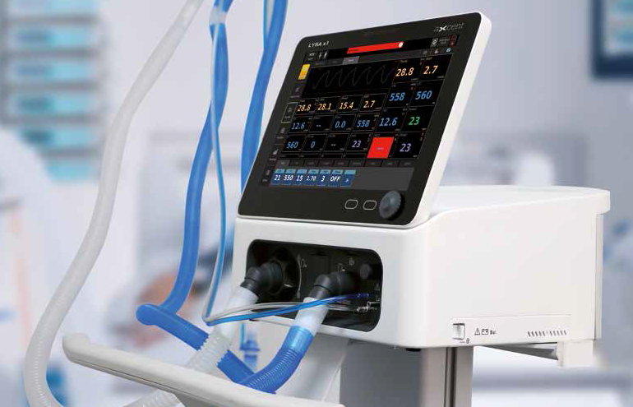
Best performing and versatile ventilation for hospital applications
A compact turbine driven ventilator with multi-function, covers the noninvasive and invasive ventilation, and is suitable for treatment of most patient type. Model 1 is versatile throughout hospital and transport.
Comprehensive ventilating modes, including APRV, PRVC, NIV are available for all your demands and for all type of patients from neonatal to adult.
A collapsible high-resolution touch-screen display makes model 1 mounted on a trolley your choice for ICU applications, as well as a high performance ventilator throughout hospital and transport.
The innovative expiration valve disassembling concept brings more ease and efficiency for the sterilization process. As your versatile assistant, model 1 is configured with O2 therapy, P-V tool, a lung titrating gold standard, etc.

Model 1: Technical Specifications
Physical Specification
Dimensions: 336 mm x 330 mm x 345 mm
(L x W x H): 664 mm x 600 mm x 1370 mm (with trolley)
Weight: Approximately 9.5 kg,
Approximately 31.0 kg (with trolley)
Screen
Display Size: 12.1 Color active matrix TFT touch
Display Resolution (H) x (V): 1280 x 800 pixels
Brightness: Adjustable
Ventilation Specifications
Patient Type: Adult, Pediatric, Neonate Invasive
Ventilation Mode:
VCV (Volume Control Ventilation)
PCV (Pressure Control Ventilation)
VSIMV (Volume Synchronized Intermittent Mandatory Ventilation)
PSIMV (Pressure Synchronized Intermittent Mandatory Ventilation)
CPAP/PSV (Continuous Positive Airway Pressure/ Pressure Support Ventilation)
PRVC (Pressure Regulated Volume Control) V +
SIMV (PRVC + SIMV)
BPAP (Bilevel Positive Airway Pressure) APRV (Airway Pressure Release Ventilation) Apnea Ventilation
Non-invasive Ventilation Mode:
PCV (Pressure Control Ventilation)
PSIMV (Pressure Synchronized Intermittent Mandatory Ventilation)
CPAP/PSV (Continuous Positive Airway Pressure/Pressure Support Ventilation) BPAP (Bilevel Positive Airway Pressure) APRV (Airway Pressure Release Ventilation)
Controlled Parameters
O2%: 21-100% (increments of 1%)
VT (Tidal Volume): Adult: 100-2000 mL (increments of 10 mL) / Pediatric: 20-300 mL / Neonate: 2-300 mL (increments of 1 mL)
f (Ventilation frequency): 1-80 bpm / Neonate: 1-150 bpm (increments of 1 bpm) fSIMV (Ventilation frequency in SIMV mode): 1-80 bpm / Neonate: 1-150 bpm (increments of 1 bpm)
I:E range: 4:1-1:10 (increments of 0.5)
Tinsp (Inspiratory time): 0.20-10 s (increments of 0.05 s)
Tslope (Time of Pressure Rising): 0-2.00 s (increments of 0.05 s)
Thigh: 0.2-30 s (increments of 0.1 s)
Tlow: 0.2-30 s (increments of 0.1 s)
Tpause: 5%-60% (increments of 1%), Off）
ΔPinsp: 5-60 cm H2O (increments of 1 cm H2O)
ΔPsupp: 0-60 cm H2O (increments of 1 cm H2O)
Phigh: 0-60 cm H2O (increments of 1 cm H2O)
Plow: 0-45 cm H2O (increments of 1 cm H2O)
PEEP: 1-45 cm H2O (increments of 1 cm H2O), Off）
Flow trigger: 0.5-15 L/min (increments of 0.1 L/min)
Pressure trigger: -10 to -0.5 cm H2O (increments of 0.5 cm H2O)
Exp% (Expiration termination level): 10-85% (increments of 5%), Auto
Technical Specifications
Apnea Ventilation
Vtapnea: Adult: 100-2000 mL (increments of 10 mL) / Pediatric: 20-300 mL / Neonate: 2-300 mL (increments of 1 mL) ΔPapnea: 5-60 cm H2O (increments of 1 cm H2O) Fapnea: 1-80 bpm (increments of 1 bpm) Apnea Tinsp: 0.20-10 s (increments of 0.05 s)
Sigh
Sigh Switch: On, Off
Interval: 20 s-180 min (increments of 1 s from 20 to 59 s, increments of 1 min from 1 to 180 min)
Cycles Sigh: 1-20 (increments of 1)
Δint.PEEP: 1-45 cm H2O (increments of 1 cm H2O), Off
Synchronized Tube Resistance Compliance Tube
Type: ET Tube, Trach Tube, Disable STRC Tube
I.D.: Adult: 5.0 -12.0 mm (increments of 0.5 mm) / Pediatric: 2.5 - 8.0 mm increments of 0.5 mm)
Compensate: 0-100% (increments of 1%)
Expiration Compliance Switch: On, Off
Monitored parameters
Numeric:
Paw | Vte | Cdyn
Ppeak | VTi | Cstat
Pplat | Oxygen concentration | Rcexp
Pmean | VTe spn | WOB
PEEP | VTe/IBW | RSBI
Insp Flow | Ftotal | NIF
Exp Flow | Fmand | P0.1
MV | Fspn | PEEPi
MV leak | Re Continuos Flow (O₂ Therapy)
MV spn | Ri

Real time Graphics:
Pressure-time waveforms: Paw-Volume Loop
Flow-time waveforms: Flow-time Loop Volumetime waveforms: Paw-Flow Loop
Control Accuracy
O2%: ±(3 vol.% +1% of setting)
TV: ±(10 mL +10% of setting) (BTPS)
Tinsp: ±0.1 s or ±10% of setting, whichever is greater
I: E 2:1 to 1:4: ±10% of setting, other range: ±15% of setting
f: ±1 bpm
fSIMV: ±1 bpm
Tslope: ±(0.2 s + 20% of setting)
PEEP: ±(2.0 cm H2O + 5% of setting) ΔPinsp: ±(2.0 cm H2O + 5% of setting) ΔPsupp: ±(2.0 cm H2O + 5% of setting) Phigh: ±(2.0 cm H2O + 5% of setting)
Plow: ±(2.0 cm H2O + 5% of setting)
Thigh: ±0.2 s or ±10% of setting, whichever is greater
Tlow: ±0.2 s or ±10% of setting, whichever is greater
Pressure Trigger: ±(1.0 cm H2O + 10% of setting)
Flow Trigger: ±(1.0 L/min + 10% of setting)
Δint.PEEP: ±(2.0 cm H2O + 5% of setting) Exp%: ±10%
fapnea: ±1 bpm
ΔPapnea: ±(2.0 cm H2O + 5% of setting) Tvapnea: ±(10 mL + 10% of setting) (BTPS) Apnea Tinsp: ±0.1 s or ±10% of setting, whichever is greater

Monitoring Accuracy
Airway pressure (Ppeak, Pplat, Pmean, PEEP,
PAP, EPAP): ±(2 cm H2O + 4% of the actual reading)
Tidal Volume: (Tvi, Tve, TVe/IBW, TVe spn): 0 ml-100 ml: ±(10 ml + 3% of the actual reading) (BTPS) 100 ml-4000 ml: ±(3 ml +10% of the actual reading) (BTPS)
Minute Volume (MV, MVspn, Mvleak): ±0.3 L/min or ±8% of the actual reading, whichever is greater (BTPS)
Frequency (ftotal, fmand, fspn): ±5% of reading or ±1bpm, whichever is greater
Inspired Oxygen (FiO2): ±(2.5 vol.% + 2.5% of the actual reading)
Resistance: 0 to 50: ±10 cm H2O/L/s
Other range: 50% of the actual reading
Compliance: 25% of the actual reading or ±10 ml/cm H2O, whichever is greater
RSBI: 0 to 999 1/(min*L): ± (3 1/(min*L) ± 15% of the actual reading)
WOB: -
NIF: ±(2 cm H2O + 4% of the actual reading) P0.1:
±(2 cm H2O + 4% of the actual reading) PEEPi: - Rcexp: -

Alarm settings
Tidal Volume: High / Low
Minute Volume: High / Low
Airway pressure: High / Low
Frequency: High / Low
Inspired Oxygen (FiO2): High / Low
etCO2: High / Low
Apnea alarm time: 5-60 s

Trend
Type: Tabular, Graphic
Length: 72 hours
Content: Monitor Parameters, Setting Parameters (Setting Ventilation mode and Parameters)

Technical Specifications
Controlled Parameters
O2%: 21-100% (increments of 1%)
Flow: 4-60 L/min
Controlled Accuracy
O2%: ±(3 vol.% +1% of setting)
Flow: ±(2 L/min +10% of setting) (BTPS)
Environmental specifications
Temperature: 5-40 °C (operating); -20 to 60 °C (storage and transport, O2sensor: -20 to 50°C)
Relative Humidity: 10-95% (operating); 10-95% (storage and transport)
Barometric Pressure: 62-106 kPa (operating);
50-106 kPa (storage and transport)
Power Battery Backup
External AC power supply
Input voltage: 100-240 V
Input frequency: 50/60 Hz
Input current: 2.5 A Max
Fuse: T2.5 AH/250 V
Internal battery
Number of batteries: One or Two (Optional)
Battery type: Build-in Lithium-ion battery, 11.25 VDC, 6400 mAh
Battery run time: 3 hours (Powered by one new fully-charged battery in standard working condition), 6 hours (powered by two new fully-charged batteries in standard working condition).
Others
Communication interface: RS-232, Ethernet, USB port, CO2 analyzer connector
Gas supply: O2 (HPO) Oxygen connector: NIST (DISS optional)
Gas supply pressure: 280-600 kPa

Model 2
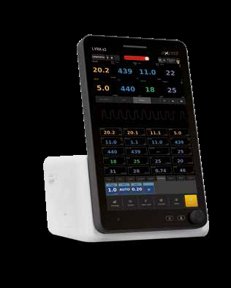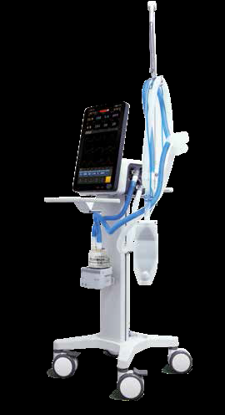
Top notch performance of Non-Invasive and Invasive Ventilation
Model 2 is a premium non-invasive turbine driven ventilator with no compromise on the performance in invasive ventilation.
User can easily switch between NIV- and IV-modes by UI operation only.
Comprehensive parameter monitoring describes the full scenario of patient’s status to the care giver.
In a busy ICU it is imperative to give the desired mechanical ventilation to the patient.
An 18.5 inch vertical layout touchscreen display makes operating of the ventilator smooth & easy.

Model 2: Technical Specifications
Physical Specification
Dimensions: 327 mm x 310 mm x 493 mm (L x W x H): 664 mm x 600 mm x 1520 mm (with trolley)
Weight: Approximately 12.0 kg, Approximately 33.0 kg (with trolley)
Screen
Display Size: 18.3 Color active matrix TFT touch
Display Resolution (H) x (V): 1080 x 1980 pixels
Brightness: Adjustable
Ventilation Specifications
Patient Type: Adult, Pediatric, Neonate Invasive
Ventilation Modes:
VCV (Volume Control Ventilation)
PCV (Pressure Control Ventilation)
VSIMV (Volume Synchronized Intermittent Mandatory Ventilation)
PSIMV (Pressure Synchronized Intermittent Mandatory Ventilation)
CPAP/PSV (Continuous Positive Airway Pressure/Pressure Support Ventilation)
PRVC (Pressure Regulated Volume Control)
V + SIMV (PRVC + SIMV)
BPAP (Bilevel Positive Airway Pressure)
APRV (Airway Pressure Release Ventilation) Apnea Ventilation
Non-invasive Ventilation Modes:
CPAP (Continuous Positive Airway Pressure)
PCV (Pressure Control Ventilator)
PPS (Proportional Pressure Support)
S/T (Spontaneous and Timed)
Controlled Parameters
O2%: 21-100% (increments of 1%)
VT (Tidal Volume): Adult: 100-2000 mL (increments of 10 mL) / Pediatric: 20-300 mL /Neonate: 2-300 mL (increments of 1 mL)
f (Ventilation frequency): 1-80 bpm / Neonate: 1-150 bpm (increments of 1 bpm) fSIMV (Ventilation frequency in SIMV mode): 1-80 bpm / Neonate: 1-150 bpm (increments of 1 bpm)
I:E range: 4:1-1:10 (increments of 0.5)
Tinsp (Inspiratory time): 0.20-10 s (increments of 0.05 s)
Tslope (Time of Pressure Rising): Thigh 0-2.00 s (increments of 0.05 s)
Tlow: 0.2-30 s (increments of 0.1 s)
Tpause: 0.2-30 s (increments of 0.1 s) ΔPinsp: 5%-60 cm H2O (increments of 1 cm H2O), Off
ΔPsupp: 0-60 cm H2O (increments of 1 cm H2O)
Phigh: 0-60 cm H2O (increments of 1 cm H2O)
Plow: 0-45 cm H2O (increments of 1 cm H2O)
PEEP: 1-45 cm H2O (increments of 1 cm H2O), Off
Flow trigger: 0.5-15 L/min (increments of 0.1 L/min)
Pressure trigger: -10 to -0.5 cm H2O (increments of 0.5 cm H2O)
Exp% (Expiration termination level): 10-85% (increments of 5%), Auto
CPAP: 4-25 cm H2O (increments of 1 cm H2O)
EPAP: 4-25 cm H2O (increments of 1 cm H2O)
IPAP: 4-20 cm H2O (increments of 1 cm H2O) Rise time: 1-5 (increments of 1)
Ramp time: 5-45 min (increments of 5 min), Off
Min P (VS minimum IPAP): 5-30 cm H2O (increments of 1 cm H2O)
Max P (VS maximum IPAP): 6-40 cm H2O (increments of 1 cm H2O)
Max P (PPV maximum pressure limit):
5-40 cm H2O (increments of 1 cm H2O)
Max V (PPV maximum volume limit): 200-3500 mL (increments of 5 ml)
Max E: 0-100 cm H2O/L (increments of 1 cm H2O/L)
Max R: 0-50 cm H2O/L (increments of 1 cm H2O/L)
PPV%: 0%-100% (increments of 1%)
Apnea Ventilation
Vtvapnea: Adult: 100-2000 mL (increments of 10 mL) / Pediatric: 20-300 mL /
Neonate: 2-300 mL (increments of 1 mL)
ΔPapnea: 5-60 cm H2O (increments of 1 cm H2O)
Fapnea: 1-80 bpm (increments of 1 bpm) Apnea
Tinsp: 0.20-10 s (increments of 0.05 s)
Sigh
Sigh Switch: On, Off
Interval: 20 s-180 min (increments of 1 s from 20 to 59 s, increments of 1 min from 1 to 180 min)
Cycles Sigh: 1-20 (increments of 1)
Δint.PEEP: 1-45 cm H2O (increments of 1 cm H2O), Off
Synchronized Tube Resistance Compliance
Tube Type: ET Tube, Trach Tube, Disable STRC Tube
I.D.: Adult: 5.0-12.0 mm (increments of 0.5 mm) / Pediatric: 2.5-8.0 mm (increments of 0.5 mm)
Compensate: 0-100% (increments of 1%)
Expiration Compliance Switch: On, Off
Monitored parameters
Numeric:
Paw | Oxygen concentration | WOB
Ppeak | Vte spn | RSBI
Pplat | Vte/IBW | NIF
Pmean | F | P0.1
Peep | FTOTAL | PeepI
Insp Flow | Fmand | PIP
Exp Flow | Fspn | EPAP
MV | Re | Pt.Trig
MV leak | Ri | Pt.leak
MV spn | Cdyn | Tot.leak
Vte | Cstat Continuous flow (O₂ Therapy)
VTi | Rcexp
Real time Graphics:
Pressure-time waveforms: Paw-Volume Loop
Flow-time waveforms: Flow-time Loop Volumetime waveforms: Paw-Flow Loop
Technical Specifications
Control Accuracy
O2%: ±(3 vol.% + 1% of setting)
TV: ±(10 mL + 10% of setting) (BTPS) Tinsp: ±0.1 s or ±10% of setting, whichever is greater
I: E: 2:1 to 1:4: ±10% of setting, other range: ±15% of setting
f: ±1 bpm
fSIMV: ±1 bpm
Tslope: ±(0.2 s + 20% of setting)
PEEP: ±(2.0 cm H2O + 5% of setting) ΔPinsp: ±(2.0 cm H2O + 5% of setting) ΔPsupp: ±(2.0 cm H2O + 5% of setting) Phigh: ±(2.0 cm H2O + 5% of setting) Plow: ±(2.0 cm H2O + 5% of setting) Thigh: ±0.2 s or ±10% of setting, whichever is greater
Tlow: ± 0.2 s or ±10% of setting, whichever is greater
Pressure Trigger: ±(1.0 cm H2O + 10% of setting)
Flow Trigger: ±(1.0 L/min + 10% of setting)
Δint.PEEP: ±(2.0 cm H2O + 5% of setting) Exp %: ±10%
CPAP: ±(2.0 cm H2O + 5% of setting) EPAP: ±(2.0 cm H2O + 5% of setting) IPAP: ±(2.0 cm H2O + 5% of setting)
Rise time: -
Ramp time: ±1 s
Min P (VS minimum IPAP): ±(2.0 cm H2O + 5% of setting)
Max P (VS maximum IPAP): ±(2.0 cm H2O + 5% of setting)
Max P (PPV maximum pressure limit): ±(2.0 cm H2O + 5% of setting)
Max V (PPV maximum volume limit): ±15% of setting
Max E: -
Max R: -
Fapnea: ±1 bpm
ΔPapnea: ±(2.0 cm H2O + 5% of setting) Tvapnea: ±(10 mL + 10% of setting) (BTPS) Apnea Tinsp: ±0.1 s or ± 10% of setting, whichever is greater
Monitoring Accuracy
Airway pressure (Ppeak, Pplat, Pmean, PEEP, PAP, EPAP): ±(2 cm H2O + 4% of the actual reading)
Tidal Volume (Tvi, Tve, TVe/IBW,TVe spn):
0 ml -100 ml: ± (10 ml+3% of the actual reading) (BTPS) / 100 ml - 4000 ml: ±(3 ml + 10% of the actual reading) (BTPS) Minute Volume (MV, MVspn, Mvleak): ±0.3 L/min or ±8% of the actual reading, whichever is greater (BTPS)
Frequency (ftotal, fmand, fspn): ±5% of reading or ±1 bpm, whichever is greater
Inspired Oxygen (FiO2): ±(2.5 vol.% + 2.5% of the actual reading)
Resistance: 0 to 50: ±10 cm H2O/L/s Other range:
50% of the actual reading Compliance: 25% of the actual reading or ±10 ml/cm H2O, whichever is greater
RSBI: 0 to 999 1/(min*L): ± (3 1/(min*L)
± 15% of the actual reading)
WOB: -
NIF: ± (2 cm H2O + 4% of the actual reading) P0.1: ± (2 cm H2O + 4% of the actual reading) PEEPi: -
Rcexp: -
Alarm settings
Tidal Volume: High / Low
Minute Volume: High / Low
Airway pressure: High / Low
Frequency: High / Low
Inspired Oxygen (FiO2): High / Low
etCO₂: High / Low
Apnea alarm time: 5-60 s
Trend
Type: Tabular, Graphic
Length: 72 hours
Content: Monitor Parameters,
Setting Parameters (Setting Ventilation mode and Parameters)
O2 Therapy
Controlled Parameters
O2%: 21-100% (increments of 1%)
Flow: 4-60 L/min
Controlled Accuracy
O2%: ±(3 vol.% +1% of setting)
Flow: ±(2 L/min +10% of setting) (BTPS)
Environmental specifications
Temperature: 5-40°C (operating); -20 to 60 °C (storage and transport, O2 sensor: -20 to 50 °C)
Relative Humidity: 10-95% (operating); 10-95% (storage and transport)
Barometric Pressure: 62-106 kPa (operating);
50-106 kPa (storage and transport)
Power Battery Backup
External AC power supply
Input voltage: 100-240 V
Input frequency: 50/60 Hz
Input current: 2.5 A Max
Fuse: T2.5 AH/250 V
Internal battery
Number of batteries: One or Two (Optional)
Battery type: Build-in Lithium-ion battery, 11.25
VDC, 6400 mAh
Battery run time: 3 hours (Powered by one new fully-charged battery in standard working condition) / 6 hrs (Powered by two new fullycharged battery in standard working condition)
Technical Specifications
Others
Communication interface: RS-232, Ethernet, USB port, CO2 analyzer connector
Gas supply: O2
(HPO) Oxygen connector: NIST (DISS optional)
Gas supply pressure: 280-600 kPa

Medical Oxygen generator
With PSA (Pressure Swing Adsorption) technology
- Oxygen concentrator with PSA (Pressure Swing Adsorption) technology to get the highly pure, quality oxygen.
- Fully automated operation
- Complete professional installation done for long life of plant
- Skid mounted construction allows for fast installation at site
- Electrical power is only INPUT cost
- Single push button operation, needs no attendant
- Automatic Switch ON & OFF as per oxygen demand

Our Advantages
- Electric Power is the only requirement in these gas generators. Cost of Oxygen production is Rs. 10 to Rs. 12 per cubic meter whereas oxygen in cylinders or in bulk may cost around Rs. 25 per cubic meter. So you get great savings.
- From Oxygen generator, you get Oxygen all 365- days. Whereas there may be interruptions in delivered Oxygen supply due to non-availability of cylinders in time or tanker shortages. No more problems of logistics or maintaining cylinders stock. You are never short of Oxygen from your own Oxygen generator.
- Our medical oxygen generators are manufactured in accordance with ASME Code & it meets Indian Pharmacopeia Oxygen 93% requirement. It is Oxygen from Air by Molecular Sieve process. “Oxygen 93%" contains not less than 90% Oxygen & not more than 96%, remainder consisting mostly of Argon and Nitrogen and thousands of such installations have proven these are safe for medical use.
- These fully automatic units produce pure oxygen at 4.8 bar pressure and is collected in a storage tank and then used through a pressure regulator at 4 bar pressure and delivered through the hospital pipeline. Pressure in Oxygen storage tank is continuously monitored and when the pressure falls below 3.5 bar, an alarm is sounded. Drop in pressure also activates the reserve supply system to be activated through the switch over panel.
- Oxygen is produced Onsite, instantaneously from ambient air freely available.
- Onsite production means, no cylinder deliveries and no risk of Oxygen shortage.
- No manpower needed for handling cylinders, a major safety advantage.

Pressure Swing Adsorption (PSA)
An economical alternative technology
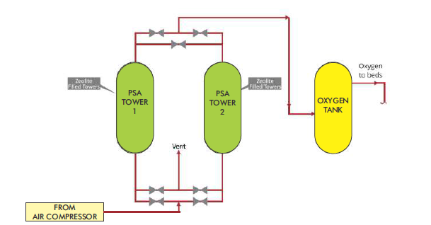
PSA (Pressure Swing Adsorption) is an economical alternative for Onsite production of Oxygen for Medical use and is in use for over 30 years in the medical industry.
Ambient air entering the compressors is 78% nitrogen, 21% oxygen, less than 1% argon and other gases.
As nitrogen is separated, the resulting product gas is up to 95.5% oxygen purity.
PSA process comprises of Zeolite filled towers and is based on the fact that different gases have the property to be attracted to different solid surfaces more or less strongly. This happens with nitrogen, which is attracted to the zeolites. As the air is compressed, the nitrogen is forced into the crystalline cages of the zeolite, and the oxygen is less adsorbed and conveyed to the end of the zeolite bed and ultimately recovered in the oxygen buffer tank.
Two zeolite beds are used together: One filters air under pressure until it gets saturated with nitrogen while oxygen passes through. The second filter begins to do the same while the first one is regenerated as nitrogen is expulsed (desorbed) by releasing the pressure. The process repeats again, storing the oxygen in a tank.

Oxygen plant – Essential blocks
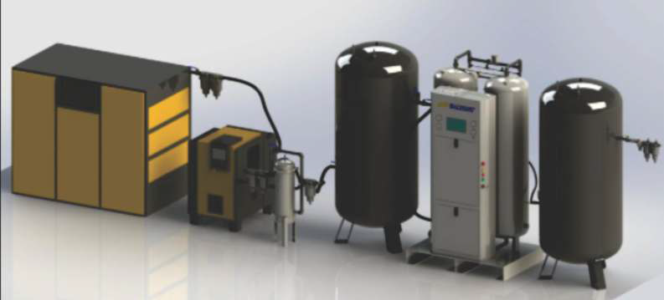
- Screw type Air Compressor with Refrigeration Dryer
- Multistage Coalescing type Oil filters to purify Air, Oil content below 0.001 ppm
- Air Receiver
- Oxygen Generator with PLC Control & Oxygen Analyzer
- Oxygen Buffer Tank
- Micro & Bacterial filtration unit

Specifications

Safety Interlocks
Be Safe
The generator is equipped with Online Digital Analyzer to measure Oxygen purity before it goes to Buffer tank. If purity falls below set points, the Oxygen supply to storage tank stops & alarm signal is displayed to indicate generator malfunction.
Drop in purity also signals for the gas supply to be diverted to the backup Oxygen supply. This is done automatically by the switchover panel. It closes Auto-shut-off valve in Oxygen supply line & actuates reserve cylinder Oxygen supply valve to maintain continuous Oxygen supply.
Pressure in Oxygen Buffer tank is continuously Oxygen Buffer vessel pressure falls below 3.5 Bar, an alarm is sounded. Monitored by Pressure Transmitter. Whenever Drop in buffer vessel pressure also activates the reserve supply system to be activated automatically through the switchover panel.

